Workshop & Book Launch, 4-5 March 2021, Leiden University

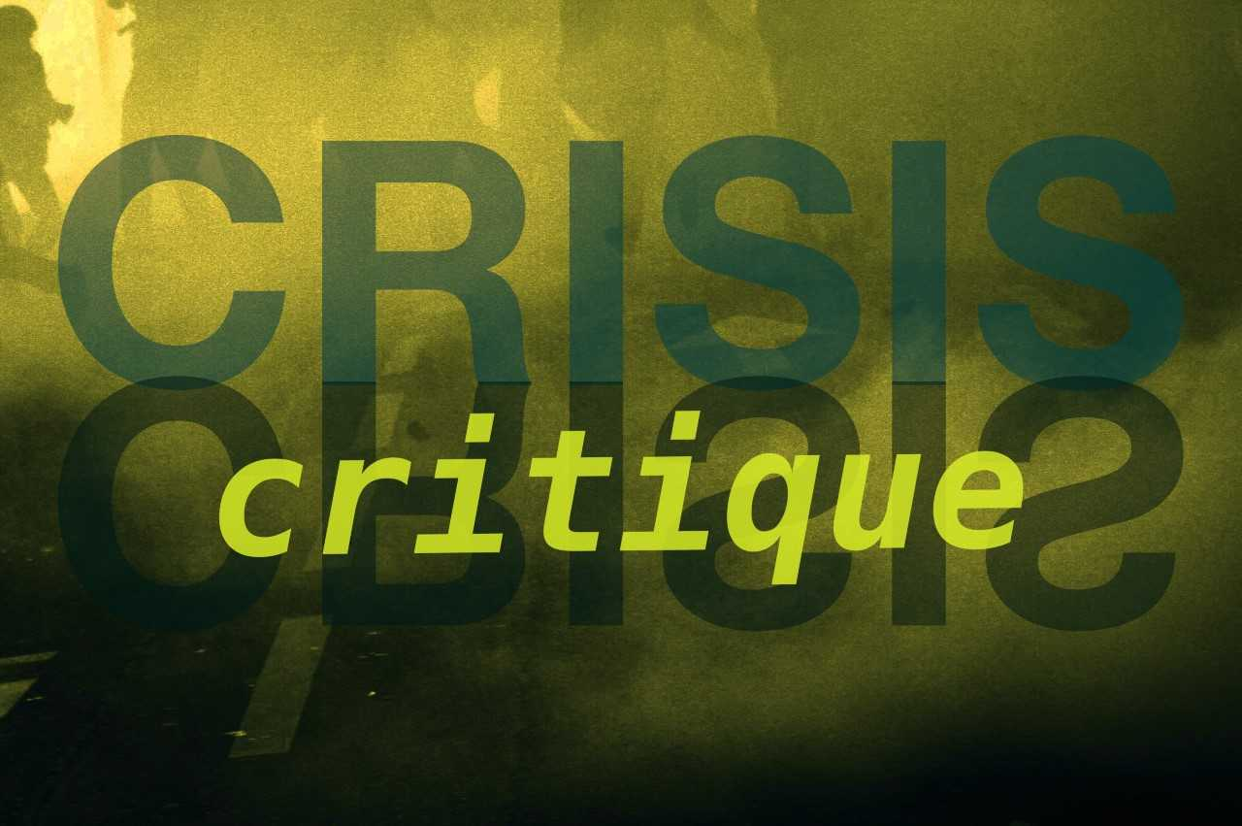

From Crisis to Critique:

Languages of Resistance, Transformation, and Futurity

in Mediterranean Crisis-Scapes

Organizers: Maria Boletsi, Janna Houwen, Liesbeth Minnaard

With keynote lectures by
Nicholas De Genova & Nilgün Bayraktar

and a masterclass by Stijn De Cauwer

Sponsored by: OSL (Netherlands Research School for Literary Studies) &
Leiden University Centre for the Arts in Society (LUCAS)

Today, the term crisis is often ‘hijacked’ by far-right, xenophobic, and anti-democratic agendas that shrink the space of political choice and the imagination of alternative futures. In this workshop we ask if there are ways to salvage crisis as a concept that can do the work of its cognate—critique—and participate in the articulation of alternative languages, literary narratives, and other modes of representation in visual, digital and social media, cinema, and art.
Our rethinking of crisis and critique will take shape through the prism of a region that has become the epicenter of various declared crises in recent years: the Mediterranean. By rethinking contemporary Mediterranean crisis-scapes, we will probe interconnections between new languages of resistance, protest, transformation, and futurity emerging primarily from literary, artistic, and other forms of cultural expression and political activism in the region, both in physical spaces and on the web. Aim of the workshop is to explore how we can move from crisis to critique; from crisis as a restrictive framework to crisis as a form of critique that triggers alternative interpretations of the present and mobilizes these as occasions for social and historical change in Mediterranean societies and beyond.
Workshop Program

Thursday 4 March 2021
13.30: Checking in

13.45: Welcome and introduction

14.00 - 16.00: Panel discussion “From Crisis to Critique”
With contributors to the volume Languages of Resistance, Transformation, and Futurity in Mediterranean Crisis-Scapes. From Crisis to Critique:
- Ipek Çelik Rappas, Koç University, Istanbul & Diego Benegas Loyo, National University of General San Martín, Buenos Aires
- Geli Mademli, University of Amsterdam
- Liesbeth Minnaard, Leiden University
- Dimitris Papanikolaou, Oxford University
Chaired by Maria Boletsi and Janna Houwen, Leiden University

16.00 – 17.00: Break

17.00 – 18.30: Keynote lecture by Nilgün Bayraktar (California College of the Arts, USA):
Refugee Futurity: From Perpetual Crisis to Critical Dystopia in Contemporary Film and Video Art

Respondent: Julian Ross, Leiden University

20.00: Film program organized in cooperation with Leiden Shorts

Friday 5 March 2021
14.00-16.00: Master Class for RMA & PhD students by Stijn De Cauwer, KU Leuven, Belgium
For more information see below, registration through OSL

16.00 – 17.00: Break

17.00-18.30: Keynote lecture by Nicholas De Genova (University of Houston, USA): title t.b.a.
Respondent: t.b.a.

Registration
The lectures and panel discussion are open to anyone who wishes to attend.
ReMA/PhD students and OSL members should register through OSL via this link.
LUCAS members and anyone else who wants to attend can register though Eventbrite via this link:
https://www.eventbrite.nl/e/workshop-from-crisis-to-critique-registration-138179720263

Participation in the Master Class is restricted to Research MA students and PhD candidates, who can earn 1 or 2 EC credits by preparing, participating and contributing to the workshop (registration through OSL).

