Summer books of 2020: History
Tony Barber selects his best mid-year reads

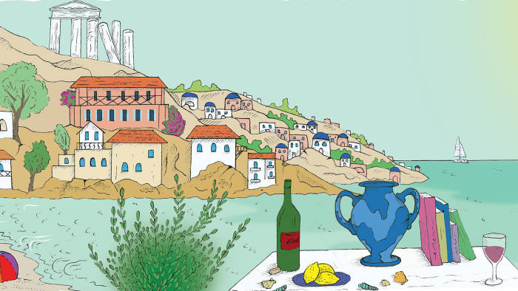
© Angelina Birkett
Tony Barber June 25 2020
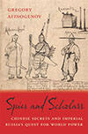 Spies and Scholars: Chinese Secrets and Imperial Russia’s Quest for World Power Gregory Afinogenov, Belknap Press, RRP £36.95/$45 The history of Sino-Russian relations appears in a much-altered light thanks to Gregory Afinogenov’s impressive new book. From the mid-17th century, the Tsarist empire outdid all other European powers in gathering political, industrial and commercial intelligence about China under the Qing dynasty. It is a little-known story, and the Georgetown University scholar tells it beautifully.

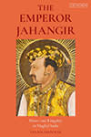 The Emperor Jahangir: Power and Kingship in Mughal India Lisa Balabanlilar, I.B. Tauris, RRP £85/$115 Jahangir, the fourth Mughal emperor of India, who ruled from 1605 to 1627, has long deserved an up-to-date, scholarly biography in English. The emperor’s political struggles, opium addiction and love for nature and art come to life in this sensitive study by Lisa Balabanlilar, a Rice University specialist on early modern Asian history.
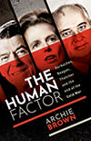 The Human Factor: Gorbachev, Reagan, and Thatcher and the End of the Cold War Archie Brown, Oxford University Press, RRP £25/$29.95 Archie Brown’s fluent narrative of the cold war’s end pays deserved tribute to Mikhail Gorbachev and his closest advisers, who in less than seven years turned Russia into a freer society than it had been in 1,000 years of history. Their reforms had the unexpected consequence of causing the Soviet Union’s collapse, leading eventually to a backlash under Vladimir Putin against western-inspired liberalism.
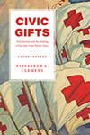 Civic Gifts: Voluntarism and the Making of the American Nation-State Elisabeth S Clemens, Chicago University Press, RRP £28/$35 Rugged individualism and a healthy suspicion of intrusive government are supposed to define the American political identity. In a carefully researched history that challenges stereotypes, Elisabeth Clemens shows that the US has often pulled through economic slumps, natural disasters and other national crises thanks to a culture of gift-giving and mutual support.
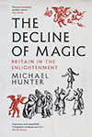 The Decline of Magic: Britain in the Enlightenment Michael Hunter, Yale University Press, RRP £25/$40 Next year will mark the 50th anniversary of Keith Thomas’s Religion and the Decline of Magic, one of the 20th century’s great historical texts. Michael Hunter’s book has a similar-sounding title, but develops a different argument in suggesting that it was sceptical humanists and freethinkers, rather than scientists, who did most to discredit traditional magic.

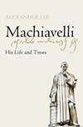 Machiavelli: His Life and Times Alexander Lee, Picador, RRP £30 Alexander Lee’s exhaustive, immensely readable life of Machiavelli sets a wholly new standard for English-language biographies of the Florentine thinker. Condemned for centuries as cynical, amoral and even satanic, Machiavelli emerges from Lee’s account as one of the Italian Renaissance’s greatest figures.
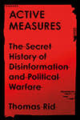 Active Measures: The Secret History of Disinformation and Political Warfare Thomas Rid, Macmillan/Farrar, Straus and Giroux, RRP £25/$30 Propaganda, lies, forgery and deception are weapons that can be every bit as effective as bombs and guns. Thomas Rid, professor of strategic studies at Johns Hopkins School of Advanced International Studies, does a wonderful job in telling the story of disinformation from the Russian Revolution to the present day.
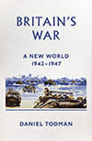 Britain’s War: A New World, 1942-1947 Daniel Todman, Allen Lane/Oxford University Press, RRP £35/$39.95 No praise is too high for Daniel Todman’s two-volume history of Britain during the second world war, an epic narrative of which this 976-page book is the concluding half. Todman, a scholar at Queen Mary, University of London, pulls together the story’s military, political, economic and social threads in masterly style.
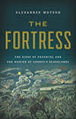 The Fortress: The Siege of Przemyśl and the Making of Europe’s Bloodlands Alexander Watson, Allen Lane/Basic Books, RRP £25/$32 If you read one military history book this year, make it Alexander Watson’s The Fortress. A specialist on the eastern front in the first world war, Watson has magnificently reconstructed one of that war’s least-known but important episodes — the Russian siege of the Austro-Hungarian fortress city of Przemyśl, now in Poland.

